Vernacular Names: Takamaka, True Kamani (Hawaii) | Scientific Name: Calophyllum inophyllum
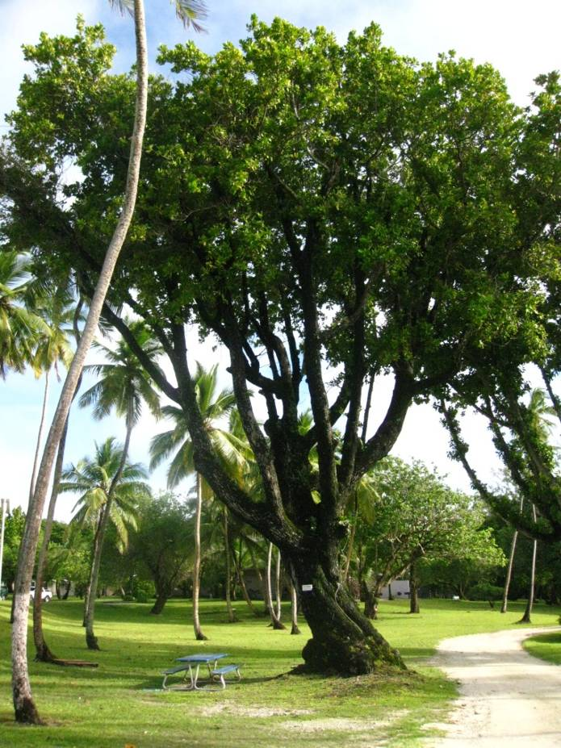 | 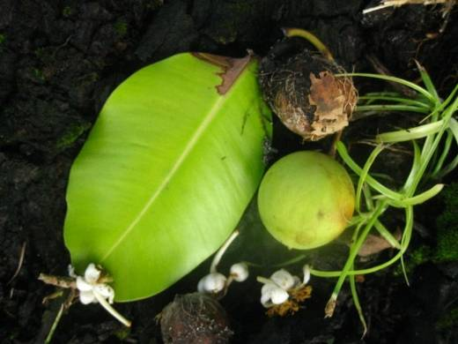  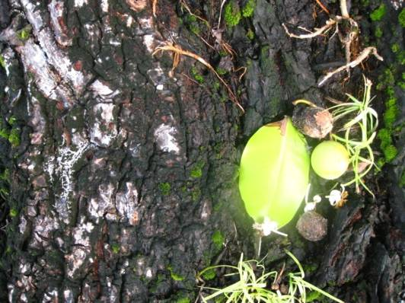
Full tree form | Details of leaf, flower, fruit & bark
Native or Introduced: Possibly introduced, established in the wild, but mainly in areas related to present and previous settlement sites.

Description: A very large hardwood tree; leaves relatively small, dark green, ovoid in shape, veins very close and parallel to each other. Small white flowers with spray of yellow anthers and long corolla tube in heads. Fruit lime-shaped and sized on a long stalk. Bark very dark, and rugged. Trees often with damaged crowns so multi-stemmed and massive lower trunks at older settlement sites. Ground beneath generally with deep leaf litter, and few other plants growing so provides an area of deep shade with no obstructions. This tree is unlikely to be confused with any other.

Habitat: Generally found in or near existing or previous settlement sites. Established both inland and in shoreline situations, with roots exposed to the tide.

Human uses: Shade at settlements. Valuable construction and boat-building timber. Oil from nuts valued medicinally in regeneration, and as bio-diesel.

Significance: An excellent shade tree, long-lived, not invasive.

Propagation: Probably possible from fruit in nursery situation, and small saplings present in large numbers beneath adult canopy. Excellent regeneration from fruits.

